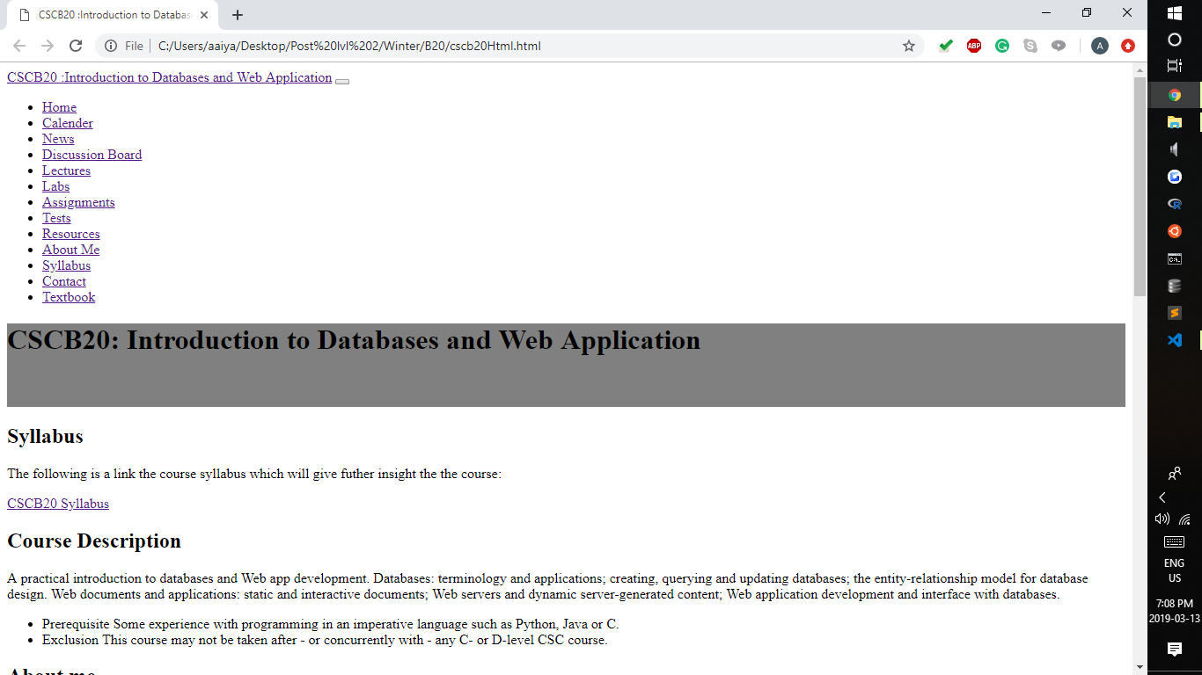

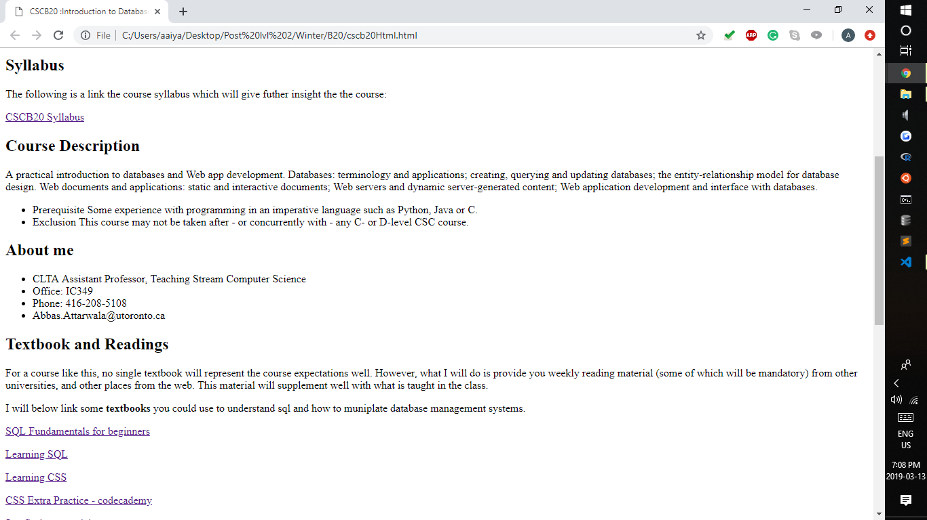

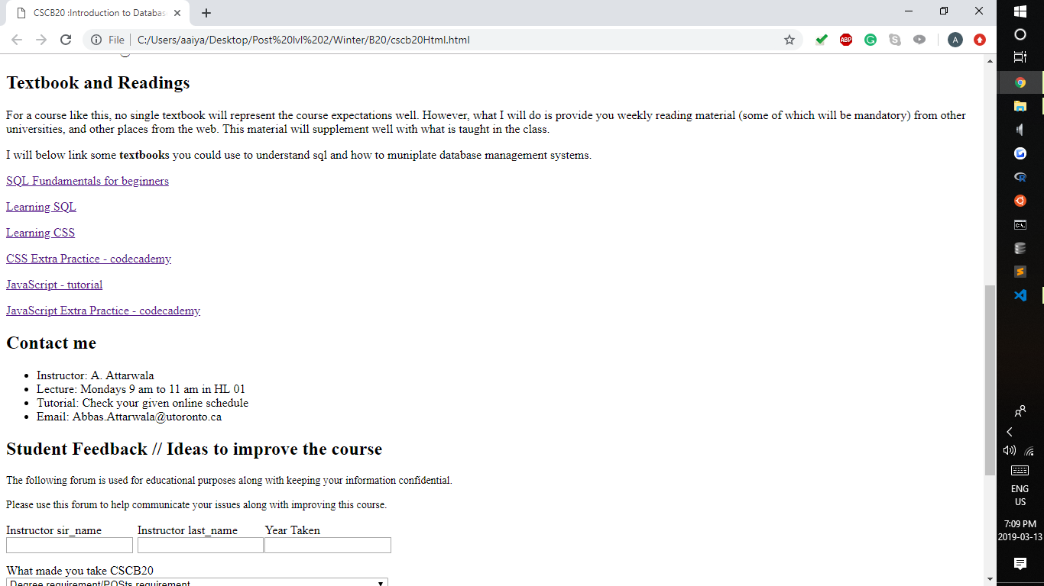

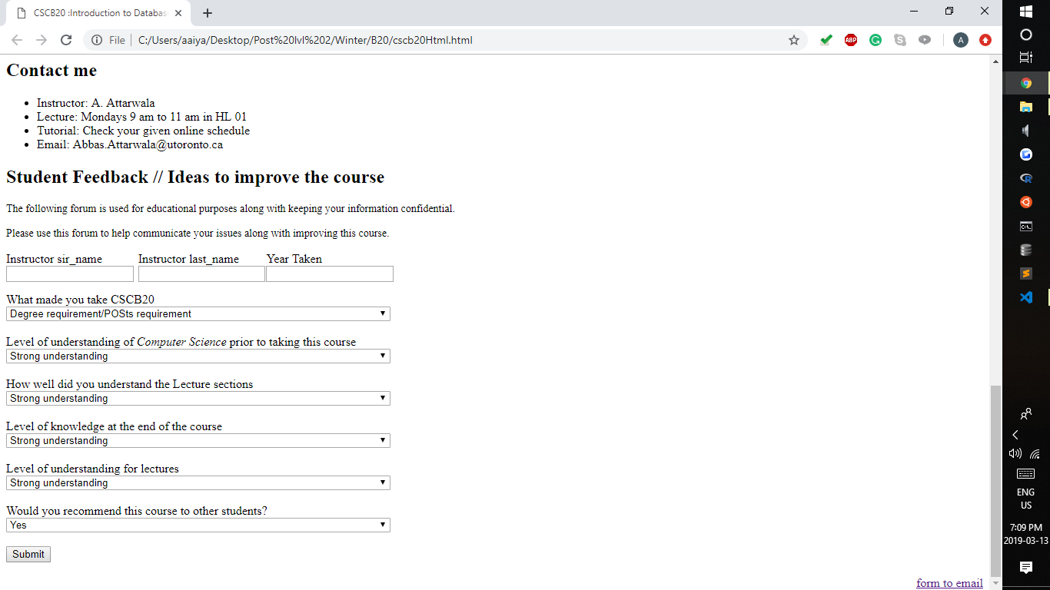

This was one of our first drafts of the mock ups.

Initially it was going to be a single page scroll down website to make it user friendly. We were going for easy UI. The first mock up had almost all the pre reqs from the assignment.

We didn’t implement a Head yet or a footer. We still had to decide how we wanted the tabs to look and how we were going to make everything responsive.

We haven't even designed the navigation in this page yet.

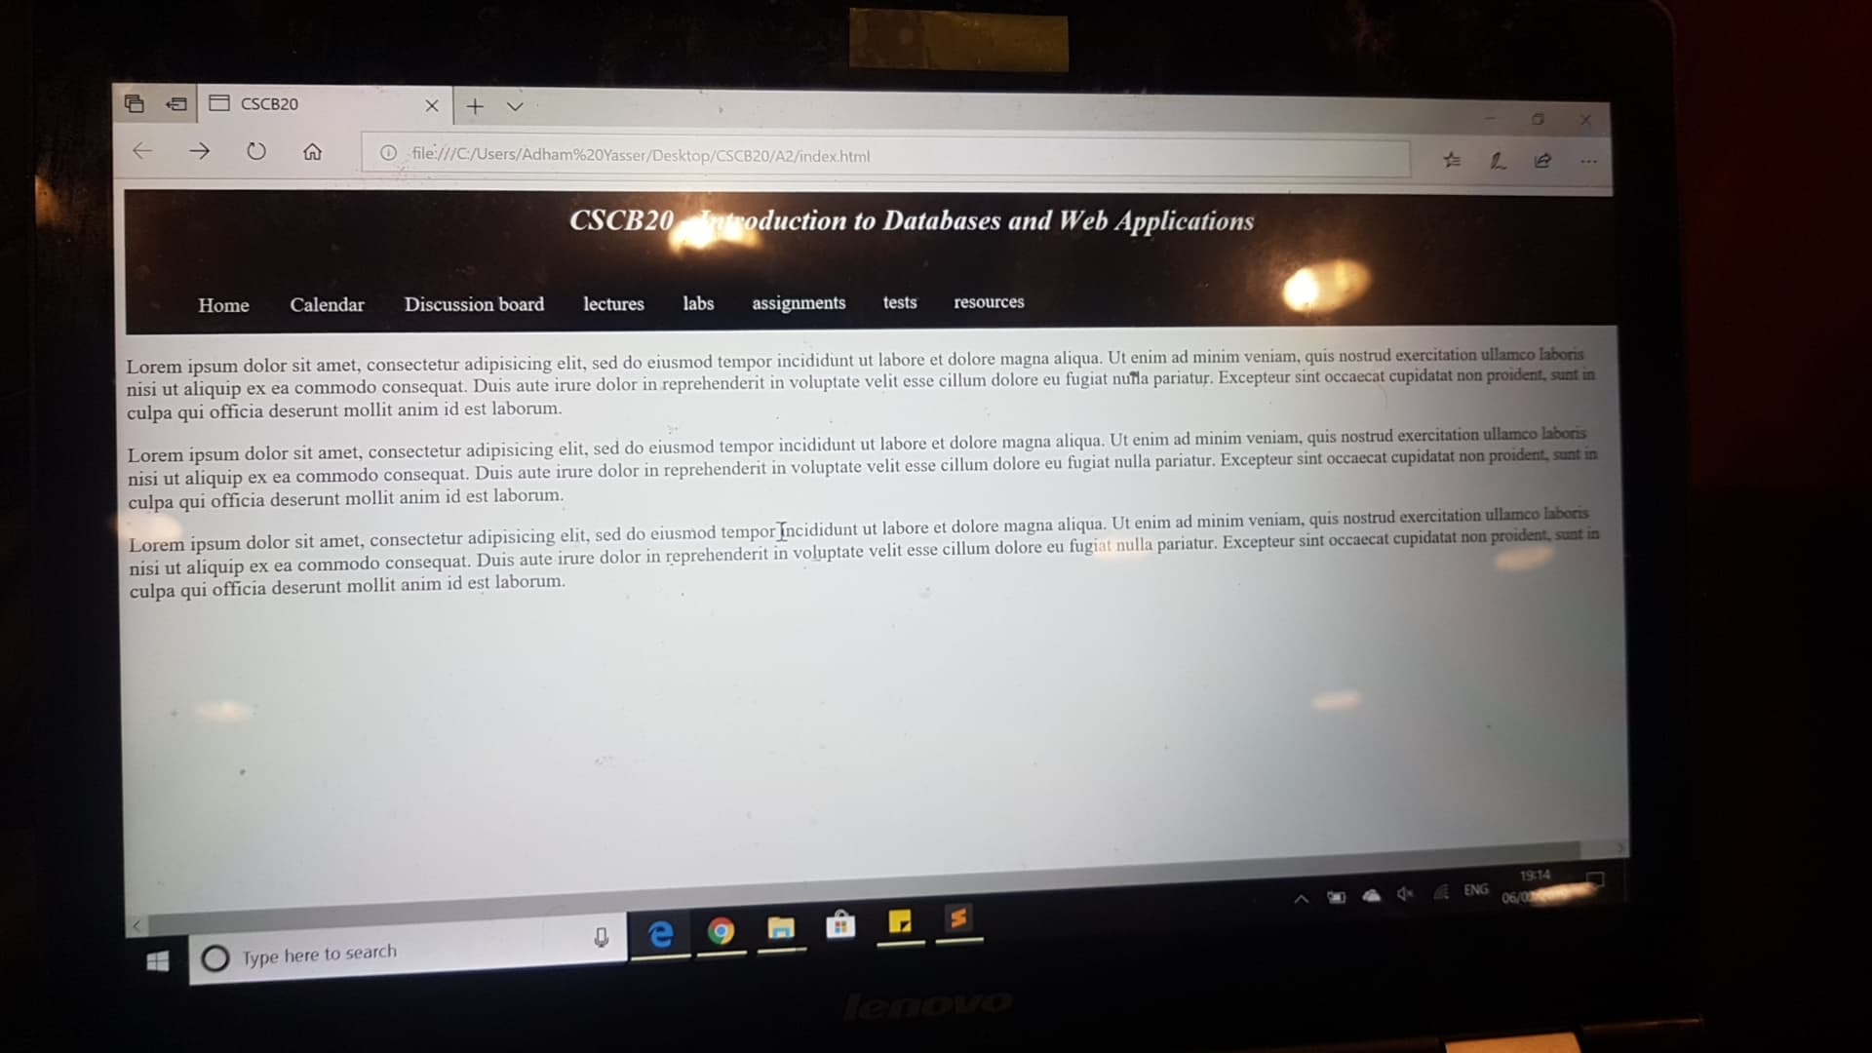

We then decided to change the navi and place it at the top and finally added some cover scheme.

At this point in time none of the tabs were yet reponsive.

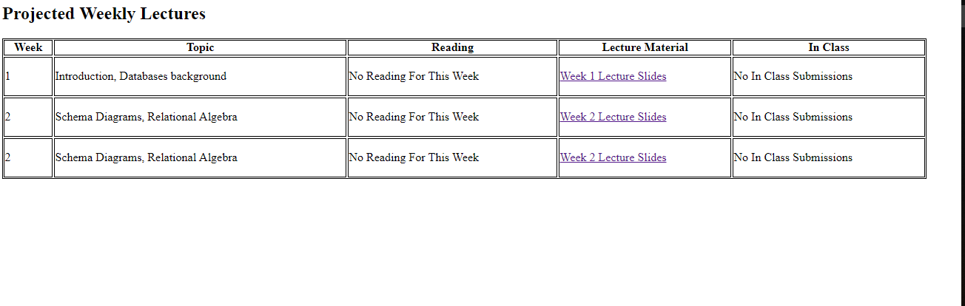

We tried to create table using div and it didn’t turn out so well so we changed out implementation style but we were headed in that area at one point in time.

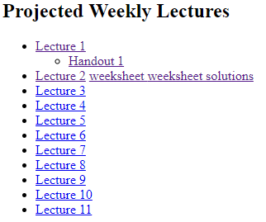

Then we tried making a scroll well out of the following html code and it was decent just didn’t seem to please the way our sight looked. It had a transition and using the hover functionality it zoomed in on the text when the move would go over it.

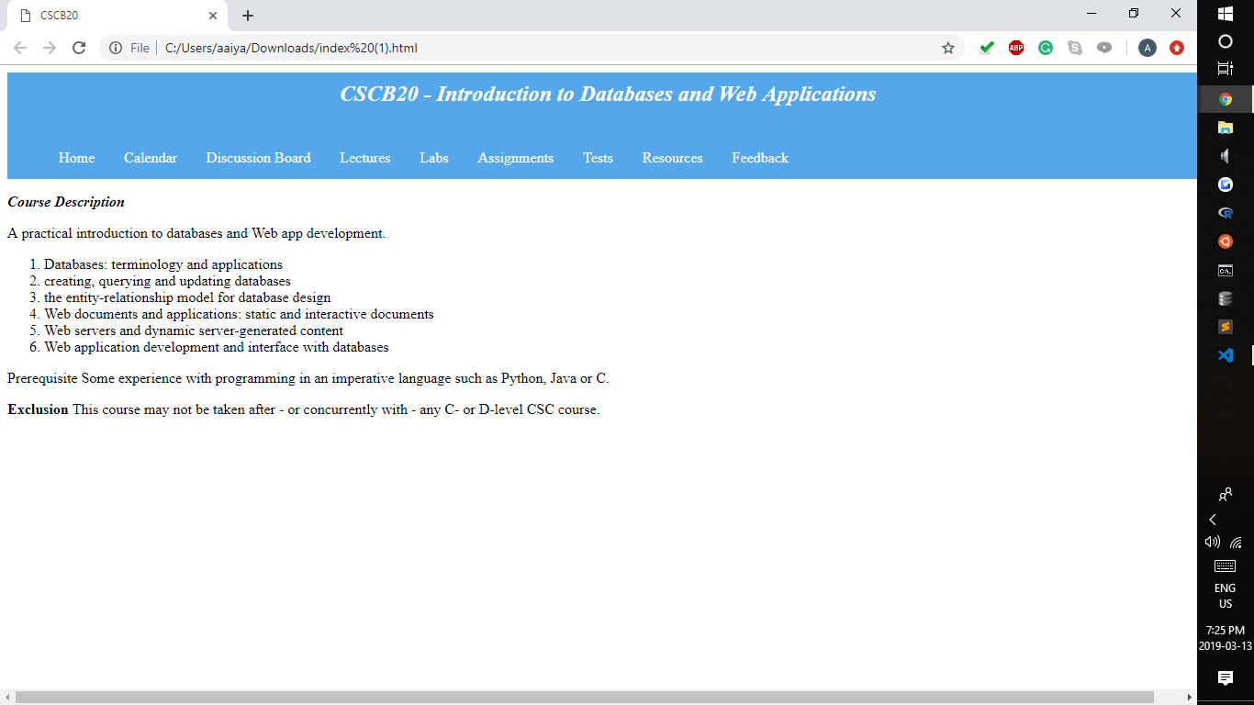

Then finally we decided to change the colour scheme. After changing the cover scheme, we decided to make the tabs responsive and carry out with the appropriate data on each tab.

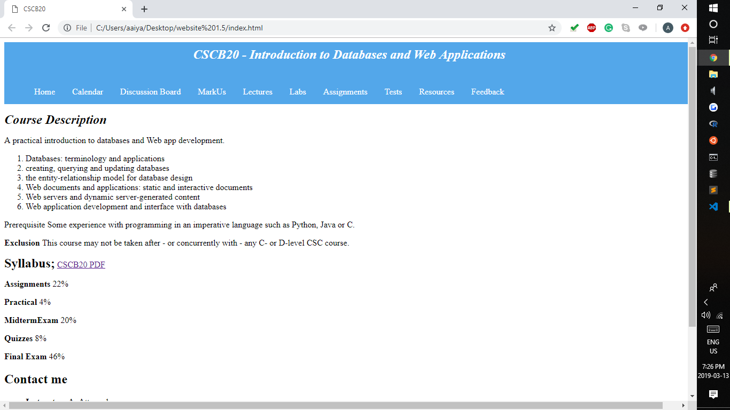

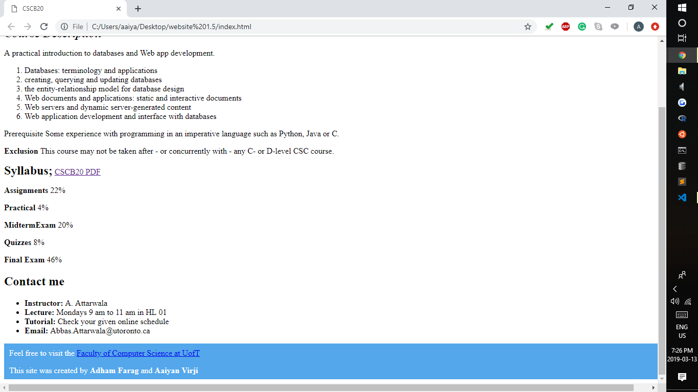

Finally, with adding a footer and all information into correct tabs. At this point we had still not figured out how to get the google calendar working. But the discussion tab was linked to piazza and markus tab was working. We had not yet figured out a good layout for lectures or labs. Feedback had the table still to show which feedback you wanted to give and resources had all links for textbooks.

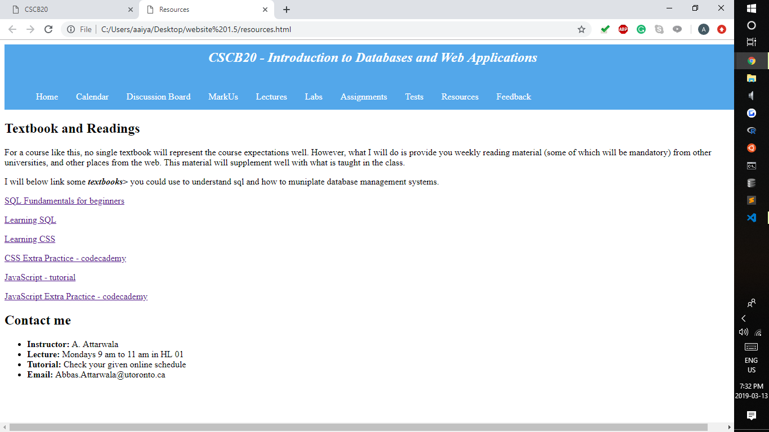

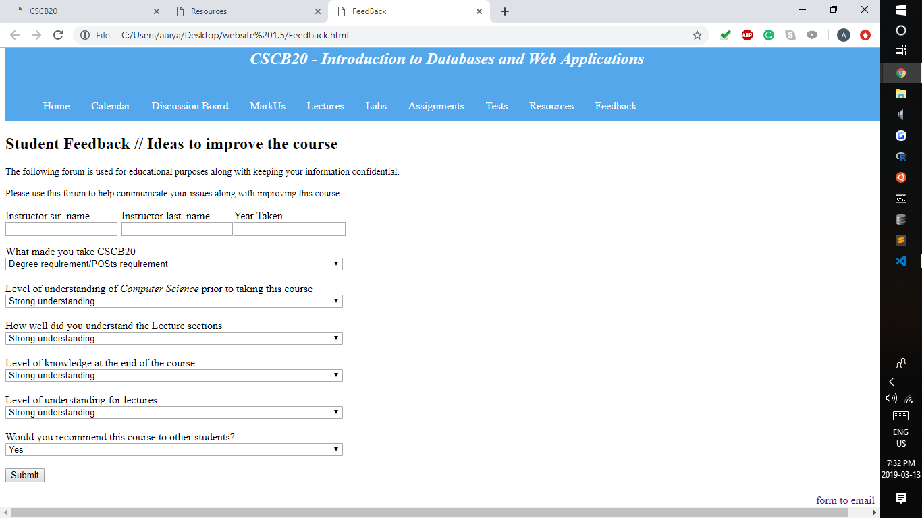

Now to our second last set of updates:

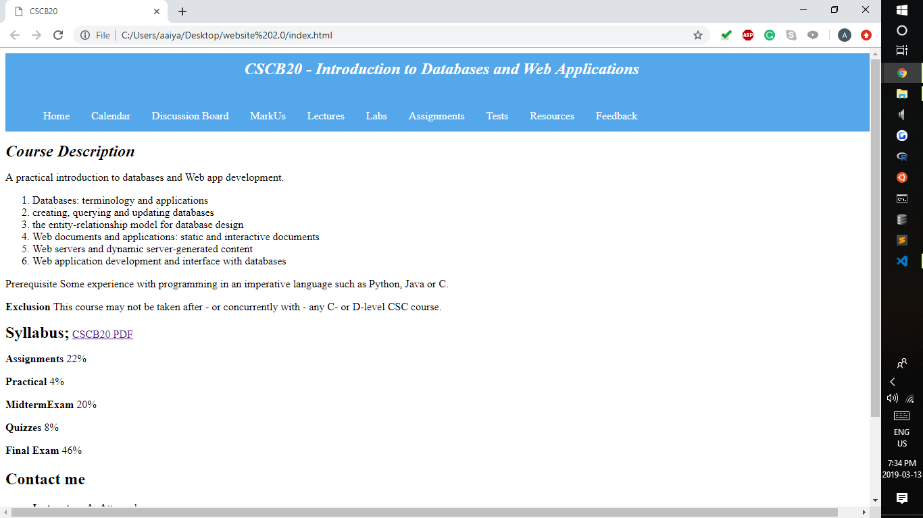

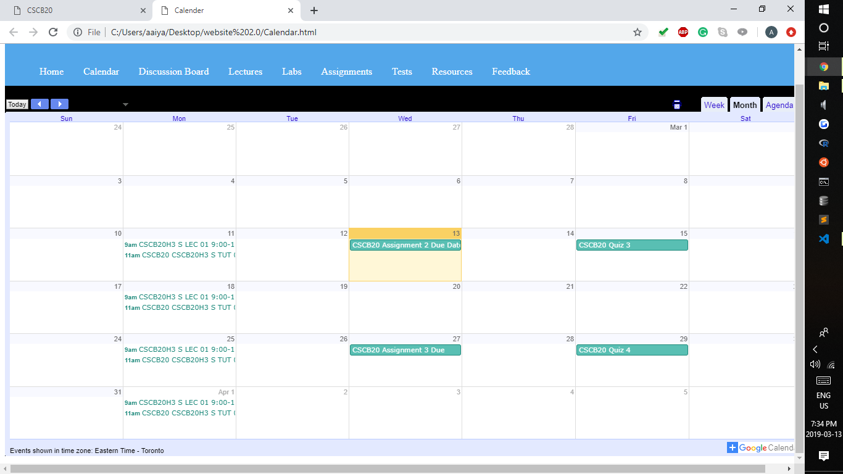

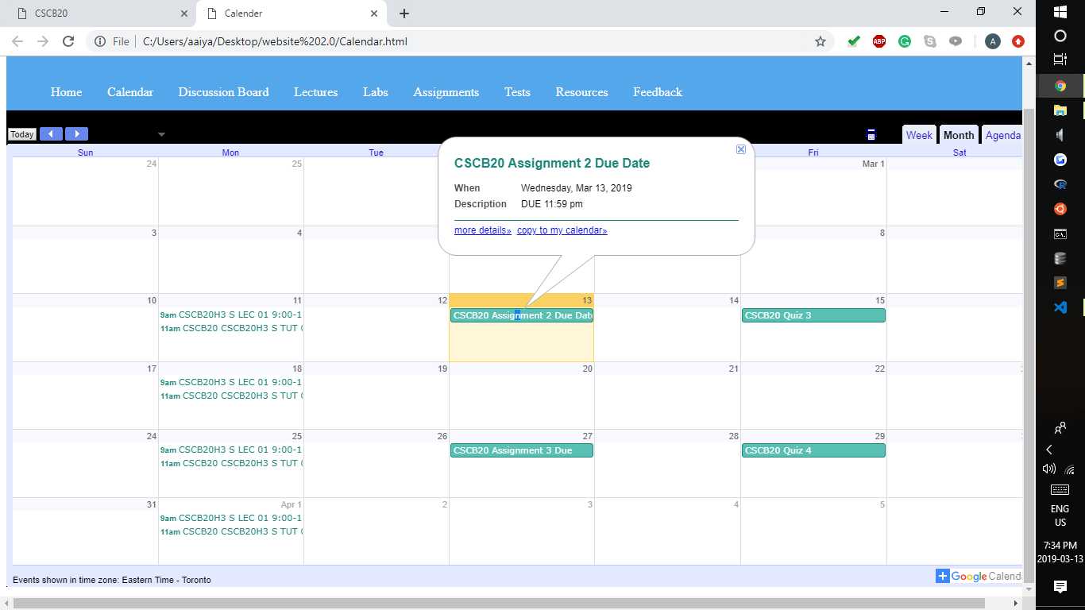

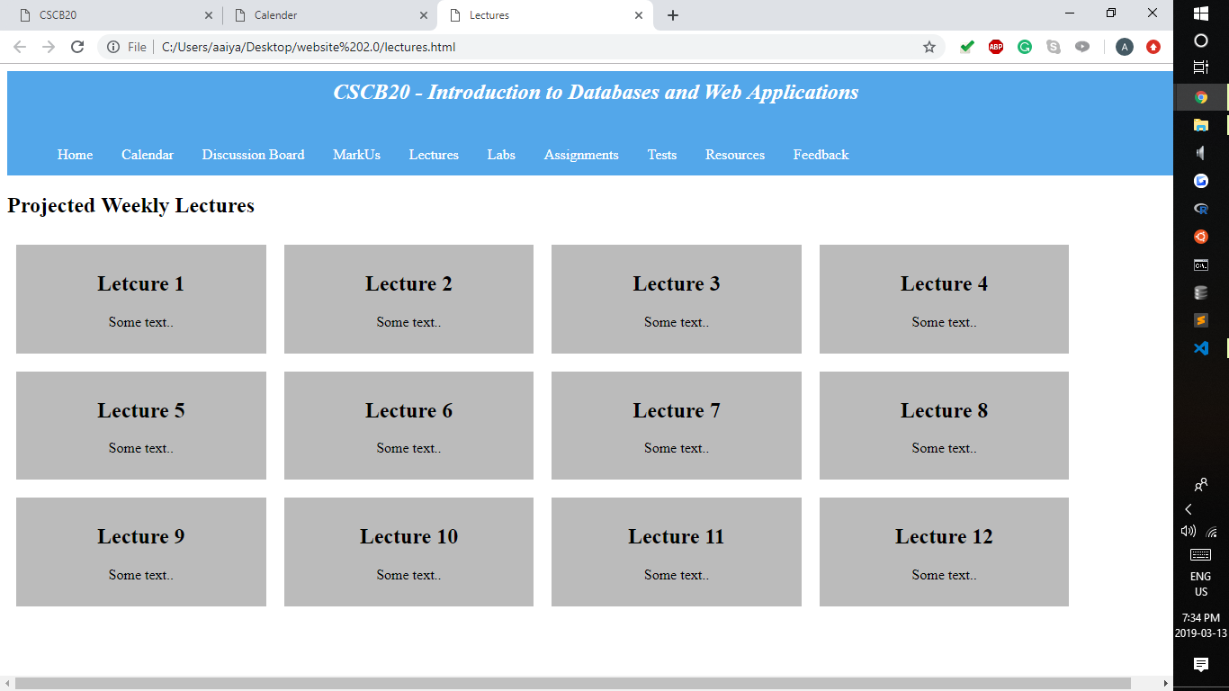

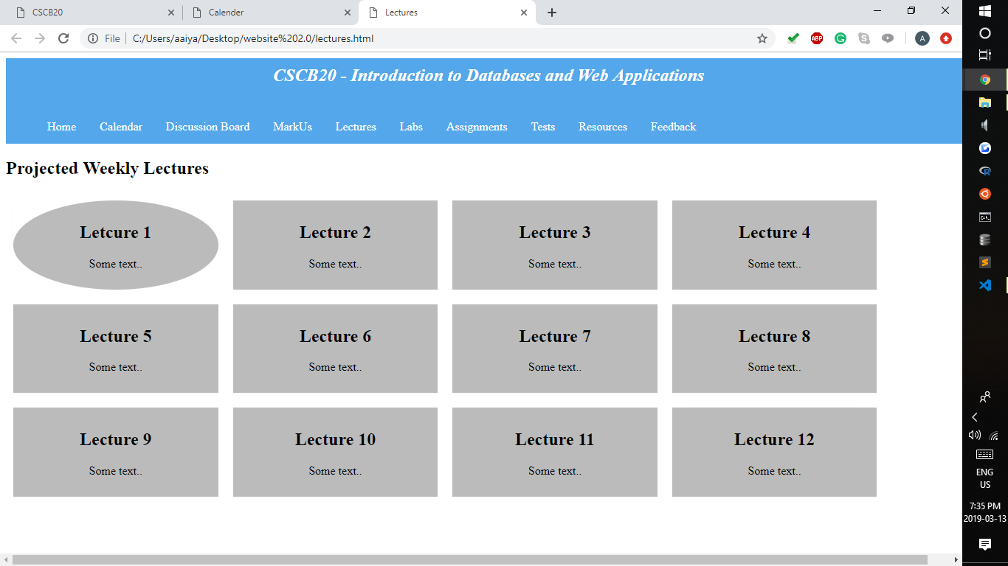

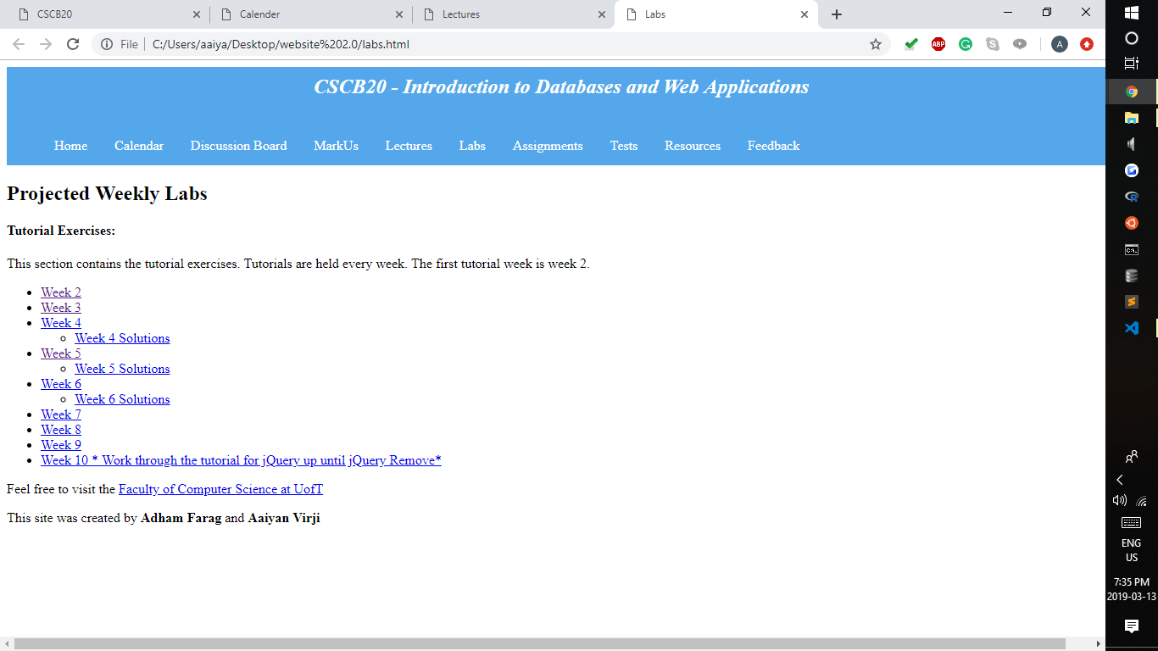

We finally added the google calendar with updates of when assignments are due. When the quizzes are due etc. Also, we changed the layout of the lecture component. As you can see, we boxed off each of the lectures. We also changed it to when you hover over each lecture it will show you the box in a different shape and it was done using transition And hover. The rest of the tabs are kind of the same.

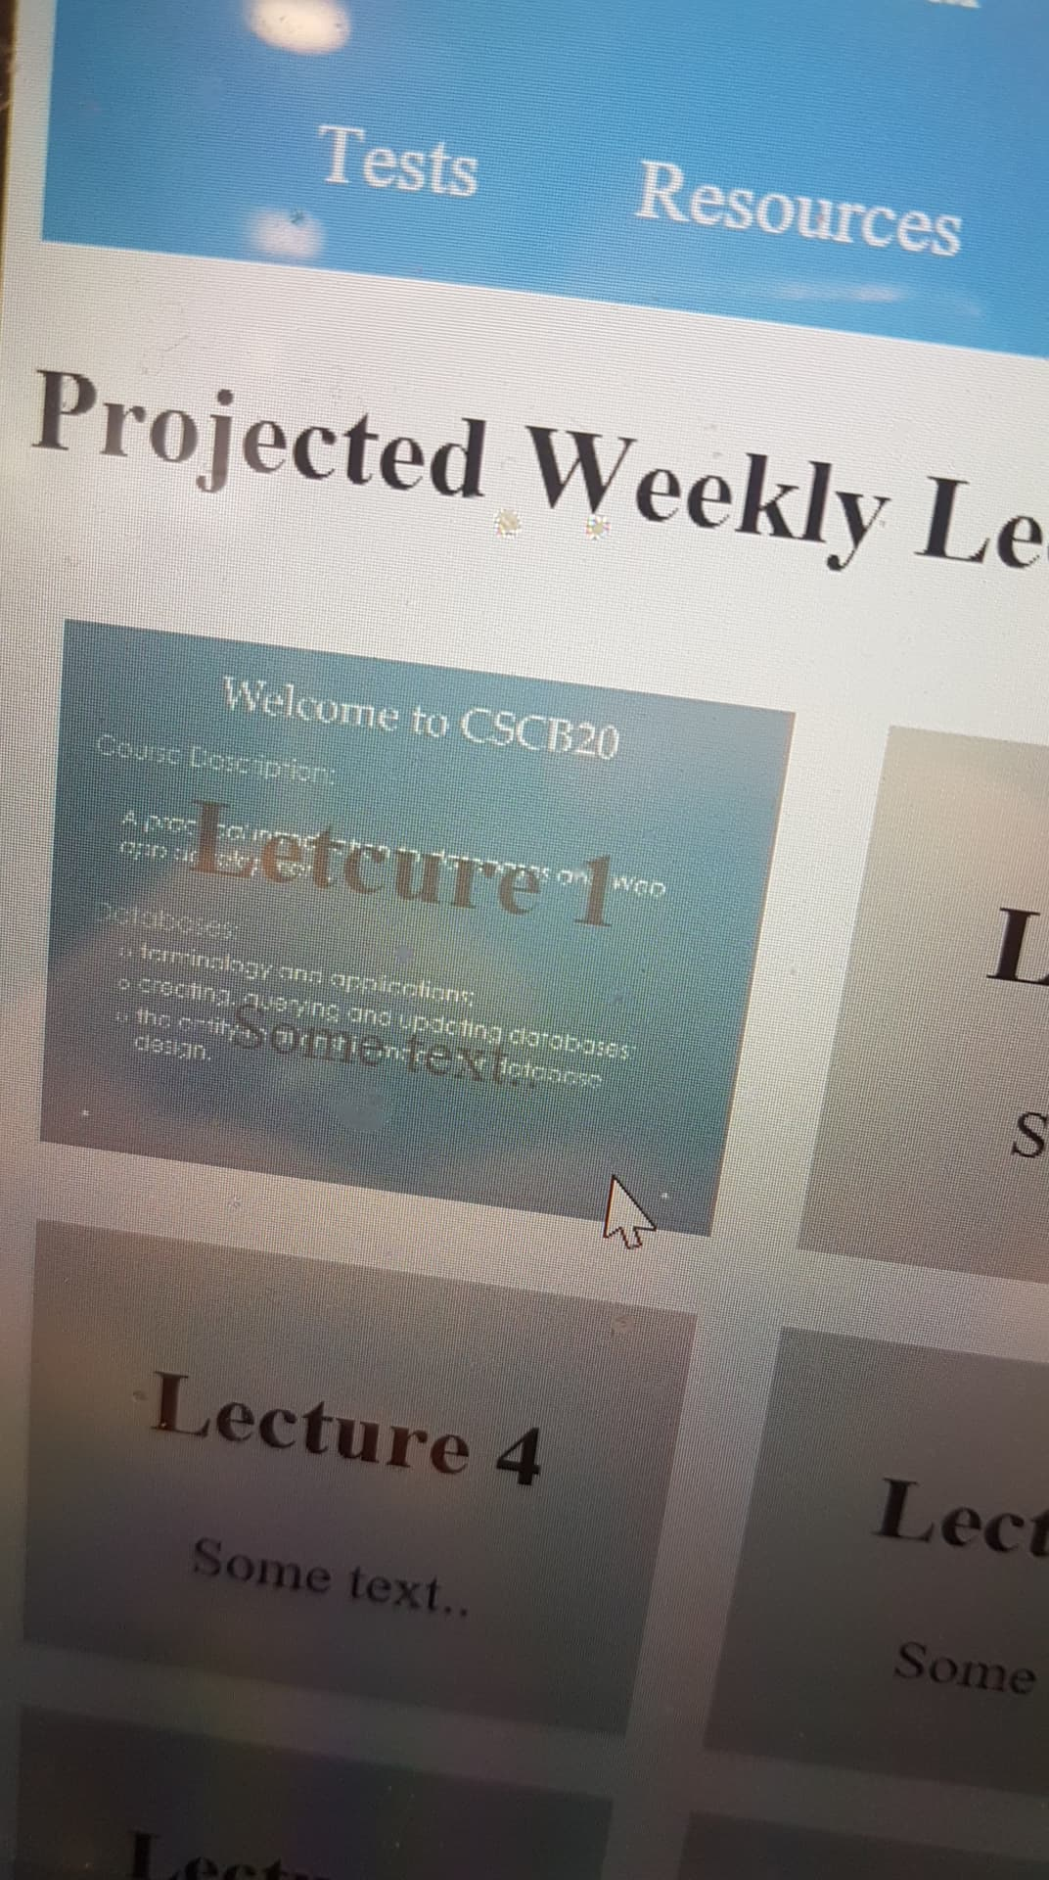

We then later changed it so that when you hover over each lecture it gives you a preview of the lecture slides so you can see the slide content.